IR Sensor Module

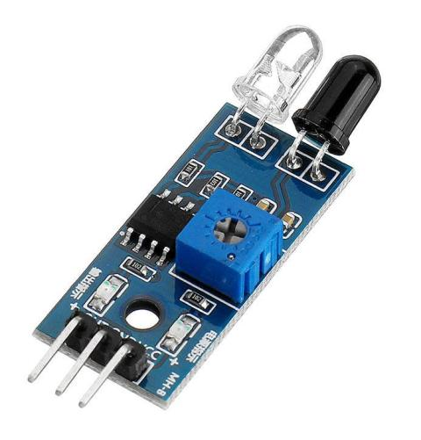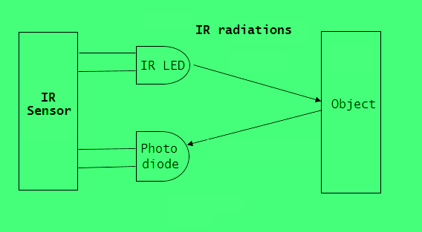

IR Sensor Module

**Pin Configuration**

|  |  |
| --- | --- |
| **Pin Name** | **Description** |
| VCC | Power Supply Input |
| GND | Power Supply Ground |
| OUT | Active High Output |

**IR Sensor Module Features**

* 5VDC Operating voltage
* I/O pins are 5V and 3.3V compliant
* Range: Up to 20cm
* Adjustable Sensing range
* Built-in Ambient Light Sensor
* 20mA supply current
* Mounting hole

**Brief about IR Sensor Module**

Proximity sensors are used to detect something approaching near. These sensors are useful in many applications like collision avoidance, obstacle detection, path following, touchless sensing, motion detection, and object detection. There are different types of proximity sensors like optical, ultrasonic, capacitive, inductive, and magnetic. The capacitive, inductive, and magnetic proximity sensors are used in specific electronic applications. The optical and ultrasonic proximity sensors have much general use and are quite common among electronics. These sensors come in a wide range according to their technology and distance of sensing.

The most simple kind of proximity sensor is the optical one. These proximity sensors are designed using active infrared sensors, consisting of a pair of IR source and an IR detector. The IR source can be either IR LED (Infrared Light Emitting Diode) or IR Laser Diode. The IR LED or IR Laser Diode transmits infrared light. This light is reflected by any object on which it falls. IR photodiodes that operate as IR detectors are placed in the sensor to capture the reflected IR radiations in a predefined range of distance and angle. Closer is the reflecting object; higher is the intensity of infrared radiation reflected, and lower IR photodiode resistance drops. As a result, IR photodiode passes through greater voltage than when there are no incident IR radiation.

# Arduino-based optical proximity sensor project (If output is Digital signal)

**Circuit diagram**

[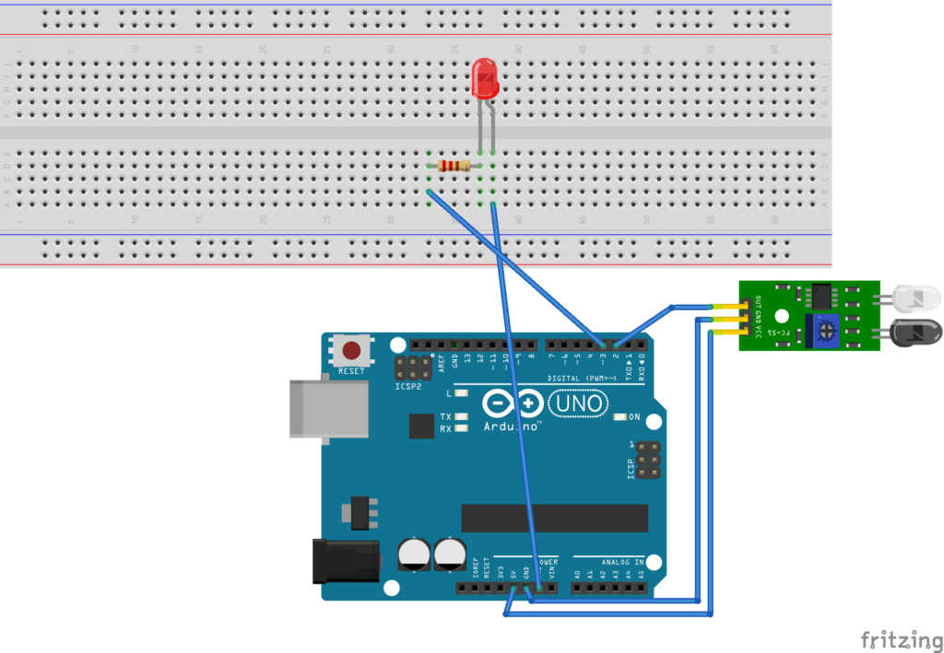](https://www.engineersgarage.com/wp-content/uploads/2020/12/P05-03.png)

**Arduino sketch**

u**nsigned int IRpin = 2;**  
**unsigned int Indicatorpin = 3;**

**void blink_indicator(){**  
**digitalWrite(Indicatorpin, HIGH);**  
**delay(200);**  
**digitalWrite(Indicatorpin, LOW);**  
**delay(200);**  
**}**

**void setup() {**  
**pinMode(IRpin, INPUT_PULLUP);**  
**pinMode(Indicatorpin, OUTPUT);**  
**}**

**void loop() {**  
**if(digitalRead(IRpin) == LOW) blink_indicator();**  
**else digitalWrite(Indicatorpin, LOW);**  
**}**

# Arduino-based optical proximity sensor project (If output is Analog signal)

**Circuit diagram**

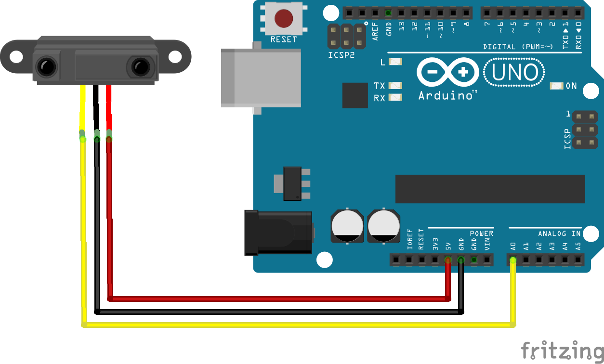

**Code**

#include <SharpIR.h> //IR sensor library

#define ir A0 //IR sensor analog output pin

#define model 20150 //or1080 depends on the model it actually means the range in cm 20-150 or 10-80

// 1080 for GP2Y0A21Y

// 20150 for GP2Y0A02Y

String Data; //To store the sentence to display

SharpIR IR_prox(ir,model); //define the sensor

void setup() {

Serial.begin(9600);

}

void loop() {

int dis_cm=IR_prox.distance(); //Read the distance in cm and store it

Data = "Distance = "+String(dis_cm)+(" cm"); //group what to display

Serial.println(Data); //display the string e.g "Distance = 40 cm"

delay(2000); //done every 2 seconds, you can change it but make it at least 50 ms

}